Jesus Nolazco

Chapter 5

Try This 5_1

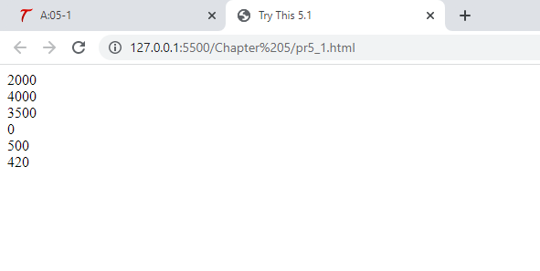

<!DOCTYPE html>

<html>

<head>

    <title>Try This 5.1</title>

</head>

<body>

    <script type="text/JavaScript" src="prjs5_1.js"></script>

</body>

</html>

let paycheck = 2000;

document.write(paycheck + "<br>")

paycheck += 2000;

document.write(paycheck + "<br>")

paycheck -= 500;

document.write(paycheck + "<br>")

paycheck -= 3500;

document.write(paycheck + "<br>")

paycheck += 500;

document.write(paycheck + "<br>")

paycheck -= 80;

document.write(paycheck + "<br>")

Try This 5_2

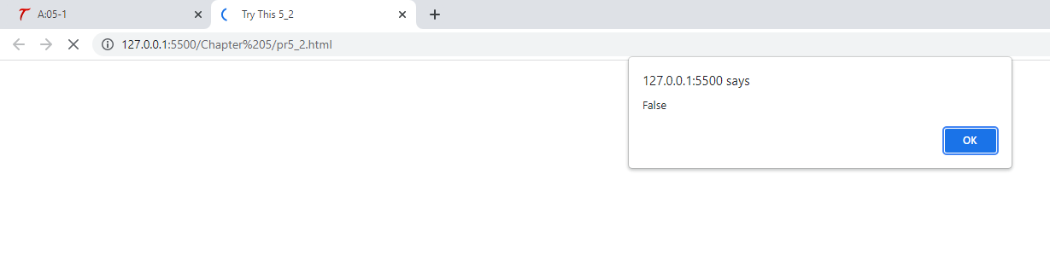

<!DOCTYPE html>

<html>

<head>

    <title>Try This 5_2</title>

</head>

<body>

    <script type="text/JavaScript" src="prjs5_2.js"></script>

</body>

</html>

let num1 = 9;

let num2 = 7;

if (num1 < num2) {

    window.alert("True");

} else {

    window.alert("False");

}